Icon.ico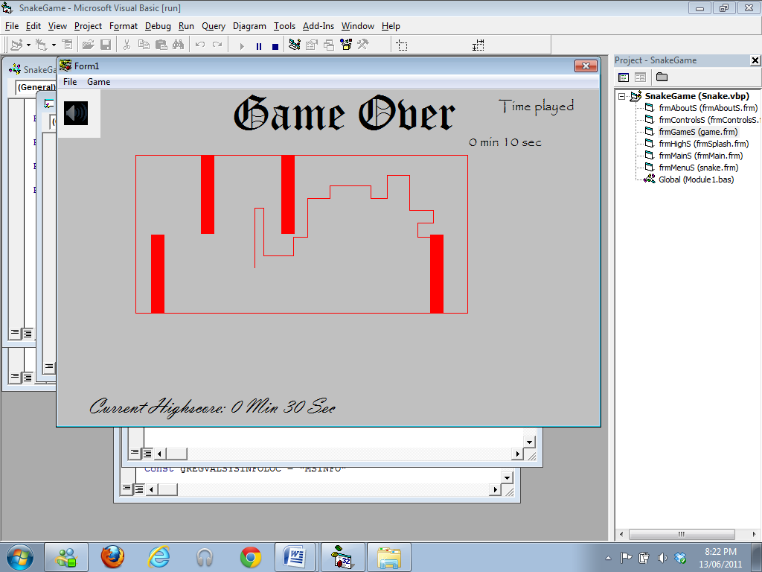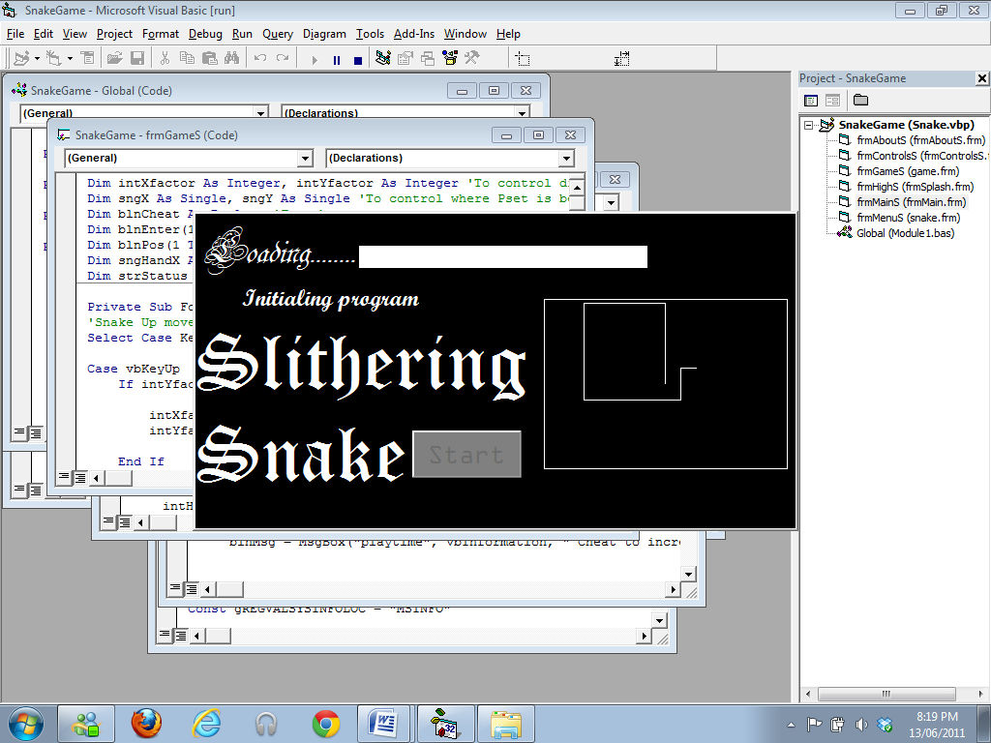

**About the game:** This is a game in which the player controls a snake in a box that continues to grow. The player looses when they hit the boundaries or the snake itself. The purpose of the game is to beat the record survival time and create a high score. The player is allowed to choose the snake color, maze type and also a handicap in the game if they wish.

**Instructions:** The objective of the game is to survive as long as possible and defeat the previous high score. The instructions for the game are:

* Main menu

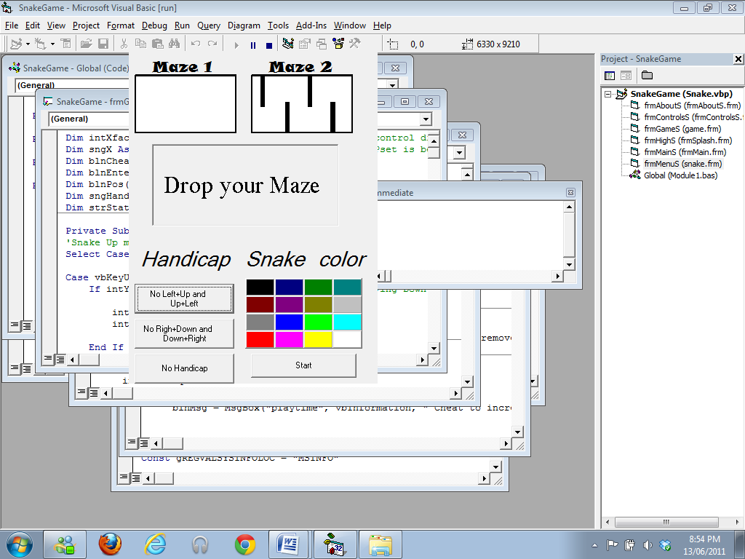

* Select the maze you wish to choose by dragging and dropping it in the box. You must do so every time you return to the main menu or you will be unable to start the game.
* (Optional) Choose a Handicap level for the snake. If you wish to remove the handicap, click on the no handicap button.
* (Optional) Choose a snake color. The default color of the snake is black.
* Press the Start button to open the game.

* Game Screen

The menu’s containing options for cheats, instructions, about, exit program and return to main menu

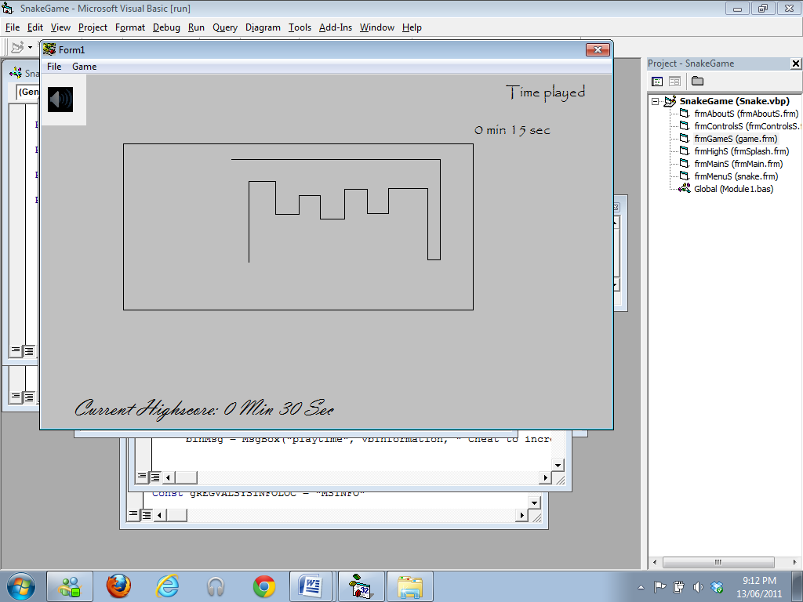

User’s played time (Resets when game starts and restarts)

Mute button

Snake

The High Score time (Default 30 seconds)

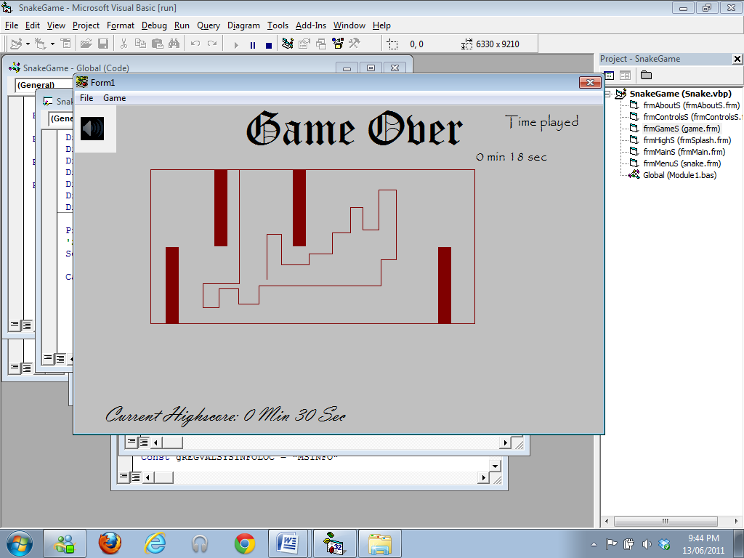

* When games starts use the directional arrow key to move the snake up, right, left or down and prevent it from hitting the wall or itself.(since the snake continuously grows, it will eventually collide with the wall or itself)
* Menus are provided on the top. The main allows you to return to main menu, reset the game or exit program and the Game allows you to open the instructions and about dialog and also a cheat entry box.
* If the snake collides with the wall or itself, Press R or click the Reset menu button to restart the game.
* If you wish to Pause/continue the game, Press P.
* If the snake collides with the wall or itself, a sound effect is played. To disable/enable this feature, click on the mute button.
* If the snake collides with the wall or itself and your time is greater than the previous high score, you will be asked to enter your name (must be longer than 2 characters and less than 20 characters). Numbers in the name entry are not accepted.
* High score Screen

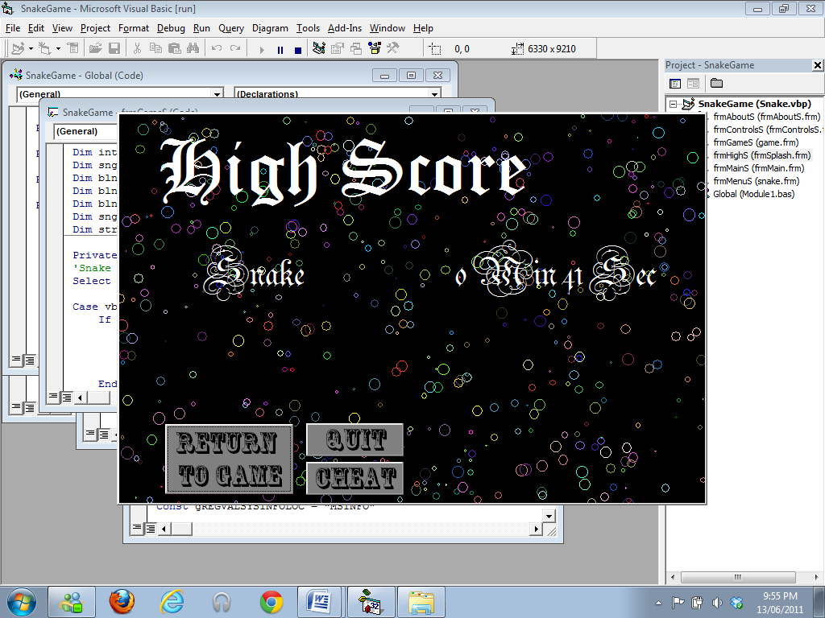

User’s High score

User Name

* The Cheat button will return a Message box, stating the cheat.
* This cheat can be used in the game for its corresponding function.
* To return to this screen you must beat your new high score.

**Cheats:** There are two cheats in this game which are displayed in the high score screen.

* The first cheat removes the maze and allows the user to move anywhere on the game screen. (displayed for score greater than 30 seconds)
* The second cheat allows the user to increase their played time in minutes to a maximum of 65 minutes. (displayed for score greater than 3 minutes)
* All cheats are activated in the game screen.
* All cheats must be entered in lowercase characters.
* If you exit the program all the cheats will be disabled.

